GSD Management
Use Case Document


 | Prepared By / Last Updated By | Prepared By / Last Updated By | Prepared By / Last Updated By | Prepared By / Last Updated By | Prepared By / Last Updated By
Name | Vijay Anand | V. Gnaneshwari | A. Ishwarya | Ramya Venkateshwaran | S. Santhoshi
Role | Team Member | Team Member | Team Member | Team Member | Team Member
Date | 28/05/2019 | 28/05/2019 | 28/05/2019 | 28/05/2019 | 28/05/2019

Table of Contents
1.0 Introduction 3
1.1 Purpose & Scope of the document 3
1.2 Intended Audience 3
1.3 Use case ‘User/Admin Registration’ 3
1.3.1 Use case attributes 3
1.3.2 Use Case Model 4
1.3.3 Business Rules 4
1.3.4 UI Requirements 4
1.3.5 UI Field Validations 6
1.4 Use case ‘User/Admin Credential Authentication’ 6
1.4.1 Use case attributes 6
1.4.2 Use Case Model 8
1.4.3 Business Rules 8
1.4.4 UI Requirement 8
1.5 Use case ‘Admin Actions’ 10
1.5.1 Use case attributes 10
1.5.2 Use Case Model 11
1.5.3 Business Rules 11
1.5.4 UI Requirement 12
1.6 Use case ‘User Actions’ 13
1.6.1 Use case attributes 13
1.6.2 Use Case Model 14
1.6.3 Business Rules 14
1.6.4 UI Requirement 14
2.0 Database Design 16
2.1 Tables Structure 16
3.0 Change Log 19

Introduction

Purpose & Scope of the document
- The purpose of this Use case document is to systematically capture requirements for the project and the system to be developed in terms of use cases. Functional use cases are captured in this document. It also serves as the input for the project scoping.

- The scope of this document is limited to addressing the use cases from a user, quality, and non-functional perspective.

Intended Audience
- All members of the project.
- Delivery assurance/excellence group.

Use case ‘User/Admin Registration’

Use case attributes
Use Case Description:

This use case deals with the capture of ‘user’ details. The Admin and User here shall be the operator of the system and will be keying in the required information into the system.

Scope:

- Admin registration.
- User registration.

Actors:

- Admin – the operator.
- User – the requestor.

Trigger:

- Click ‘Sign Up’ button in the ‘User Registration’ page.
- Click ‘Sign Up’ button in the ‘Admin Registration’ page.

Pre-Condition:

User and Admin are being able to access the ‘Registration’ Page.

Post Condition:

User and Admin is on the ‘Registration’ page & they can submit details to get redirected to the ‘GSD Login’ page upon click of ‘Submit ‘Button.

Flow of Events:

User/ Admin at Registration Page → Click respective Register button→ User/Admin details are submitted and added onto the database →User/Admin are redirected to the Login Page.

Primary Scenario:

A new User/Admin – is able to click Register button and able to provide his details and get enrolled in the system. He is redirected to the Login page to enter his provided details for validation.

Use Case Model
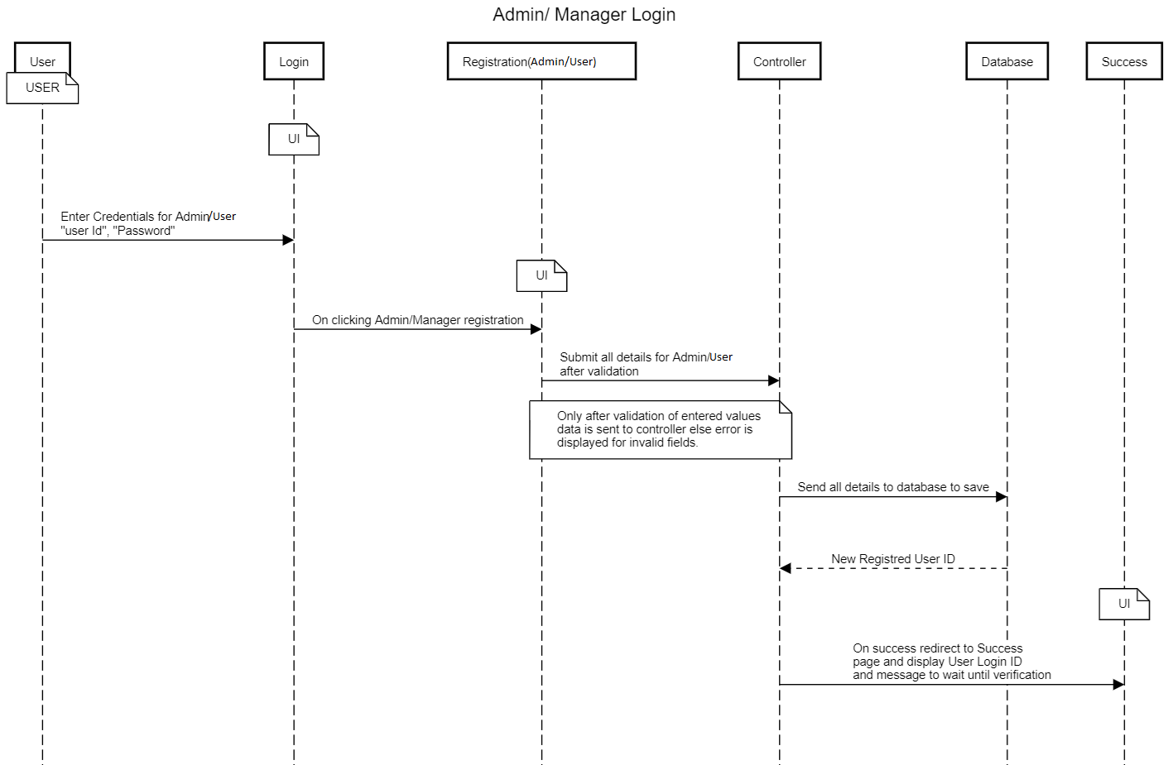

Business Rules

Business rules should be defined using the following attributes: -

- When the user clicks on the ‘Sign Up button, it should be re-directed to Registration form.
    - User must fill some of the basic attributes/fields as mentioned below in requirement: First Name, Last Name, Age, Gender, Contact Number, Address, City, Zip code.
- Clicking ‘Sign Up’ should validate the datatype constraints for each field.
- Post-successful field level validation, information is stored in the database.
- Upon saving the information in the database, display the message ‘Your details are submitted successfully’.

UI Requirements
Here is a prototype of how the Home page will look like:

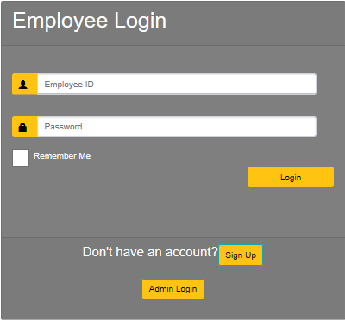

Here is a prototype of how the User Registration page will look like:

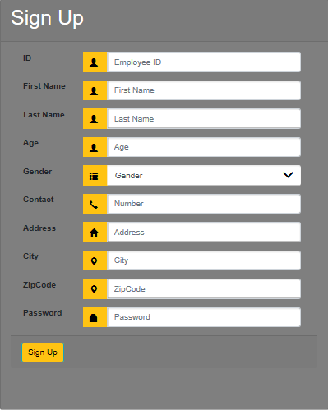

Here is a prototype of how the Admin Registration page will look like:

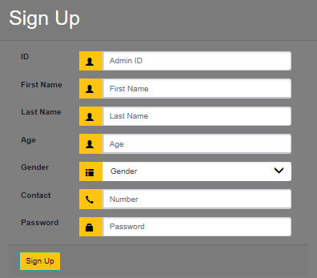

UI Field Validations
Please refer to the below requirements for field level validations:

- The fields First Name, Last Name, Age, City and Zip code are mandatory.

Use case ‘User/Admin Credential Authentication’

Use case attributes
Use Case Description:

This use case deals with the authentication of the user credentials. The ‘User/Admin’ here shall be the operator of the system and will be performing the required tasks.

Scope:

- User/Admin credentials authentication.

Actors:

User/Admin – the operator.

Trigger:

Click ‘Login’ button, after keying in ‘User ID’, ‘Password’ fields.

Pre-Condition:

User/Admin being able to access the Login page.

Post Condition:

User/Admin is in the GSD home page and is able to perform the following tasks.

Flow of Events:

User at Login page → Key in ‘User ID’ & ‘Password’ field and click submit→ User credentials are validated →User GSD Home page is displayed → Raise GSD → submit.

Admin at Login page → Key in ‘User ID’ & ‘Password’ field and click submit→Admin credentials are validated → Admin GSD Home page is displayed → View all GSDs → Release GSDs.

Primary Scenario:
A registered User/Admin – is able click ‘Login’ submit button, after keying in ‘User ID’ & ‘Password’ field and get his credentials authenticated with the existing database entry.

Alternative Scenario:
A registered User/Admin – is able click ‘Login’ button, after keying in ‘User ID’ & ‘Password’ field and unable to get his credentials authenticated. The user is presented with relevant error messages:

- Invalid User ID.
- Incorrect Password.
- Account not verified.

Use Case Model

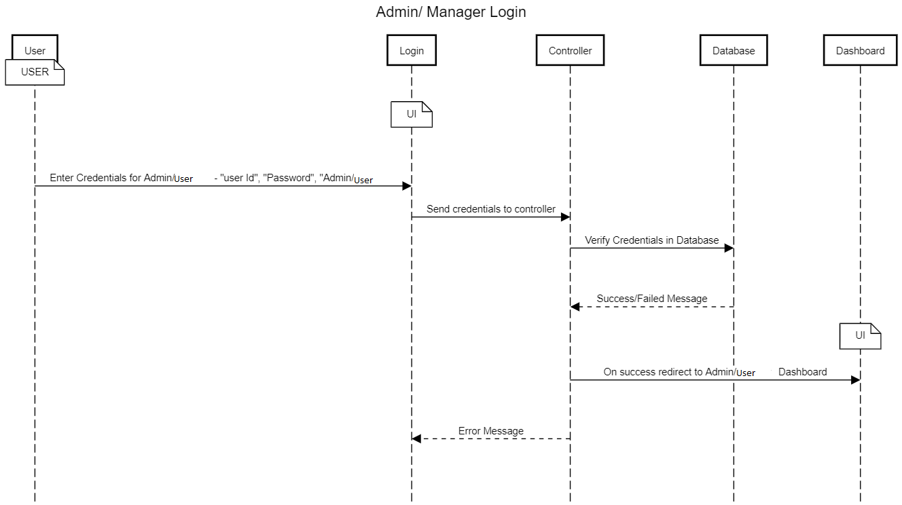

Business Rules
Business rules should be defined using the following attributes: -

- A registered User/Admin – is able click ‘Login’ lbutton, after keying in ‘user ID’, ‘Password’ field & get his credentials authenticated with the existing database entry.

UI Requirement

Here is a prototype of how the User Login will look like:

Here is a prototype of how the Admin login will look like:

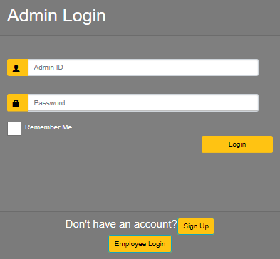

Use case ‘Admin Actions’

Use case attributes
Use Case Description:

This use case deals with the actions performed by the Admin. The Admin of the system will be able to perform the following tasks.

Scope:

- View all Users raised GSDs.
- Release the raised GSDs.

Actors:

Admin – the operator.

Trigger:

Click ‘View All Employee GSD’ button to display pending requests in a new page.

Pre-Condition:

Admin being able to access the GSD Database.

Post Condition:

Admin is in the GSD portal and is able to perform the permitted tasks.

Flow of Events:

Admin at GSD portal →Clicks View All Employee GSD →Selects one of the raised GSD→Releases the selected GSD.

Primary Scenario:
A Registered Admin – is able to select given options from GSD portal according to work requirement.

Use Case Model

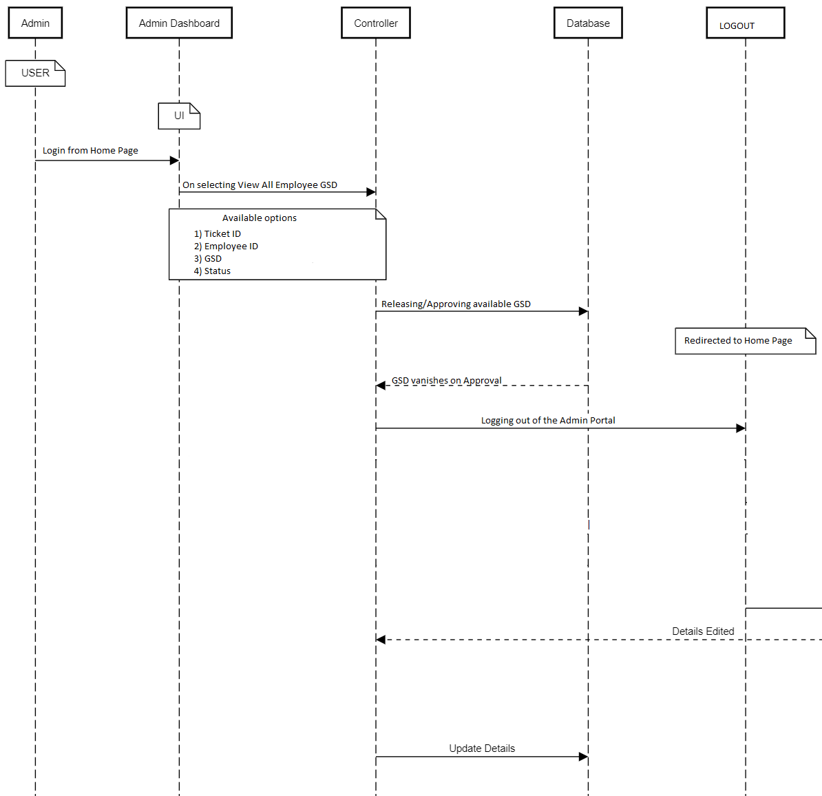

Business Rules
Business rules should be defined using the following attributes: -

- Admin – is able to view, release all the raised GSDs of the Users.

UI Requirement
Here is a prototype of how the Admin GSD Home page will look like:

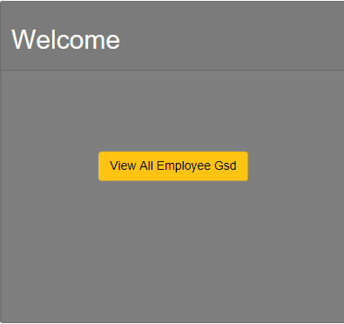

Here is a prototype of how the Admin View All Employee GSD Tab will look like:

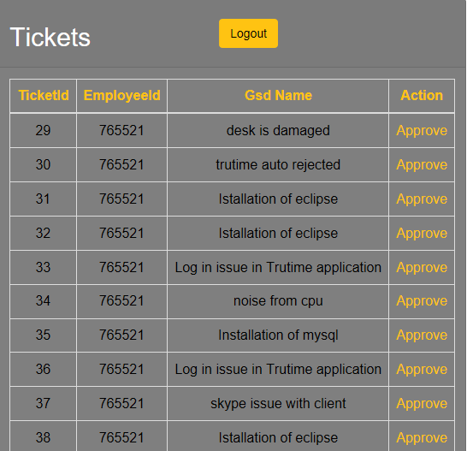

Use case ‘User Actions’

Use case attributes
Use Case Description:

This use case deals with the actions performed by the User. The ‘user’ here shall be the Employee of the system and will be performing the required tasks.

Scope:

- Search GSD.
- Raise GSD.
- View respective GSD.

Actors:

User – the Employee.

Trigger:

Click ‘Raise GSD’ to search and select from all GSDs available.
Click ‘Track Request’ tab on GSD portal to view history of raised GSDs by him.
Click ‘Notification’ tab on GSD portal to view the status of the raised GSDs.

Pre-Condition:

User being able to access the GSD portal.

Post Condition:

User is in the GSD portal page and is able to perform the permitted tasks.

Flow of Events:

User at GSD portal → searches GSD →raises selected GSD→redirected to portal.
User at GSD portal → clicks Track Request Tab →views history of GSDs.
User at GSD portal → clicks Notification Tab → views status of GSDS.
User at GSD portal → clicks Logout Tab →redirected to Homepage.

Primary Scenario:
A registered User – is able to select given options from dashboard according to work requirement.

Use Case Model

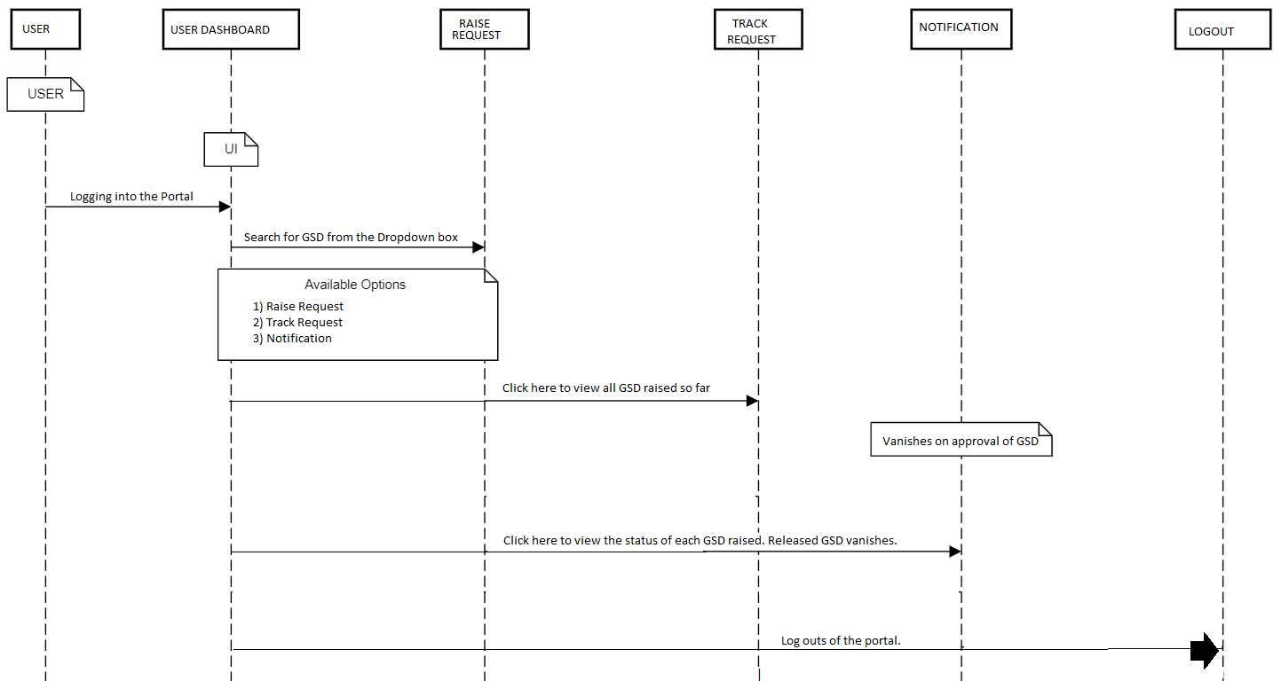

Business Rules
Business rules should be defined using the following attributes: -

- A User– is able to search, raise and view all his GSDs.

UI Requirement
Here is a prototype of how the Raise Request Tab will look like:

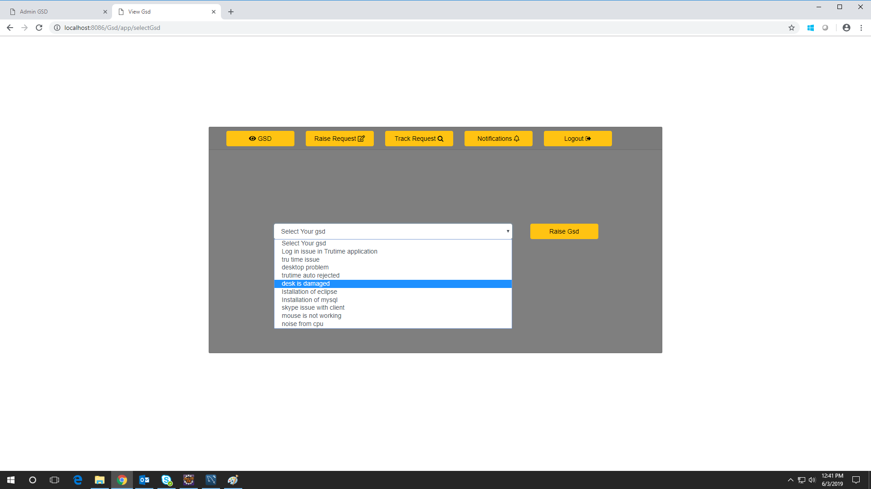

Here is a prototype of how the Track Request Tab will look like:

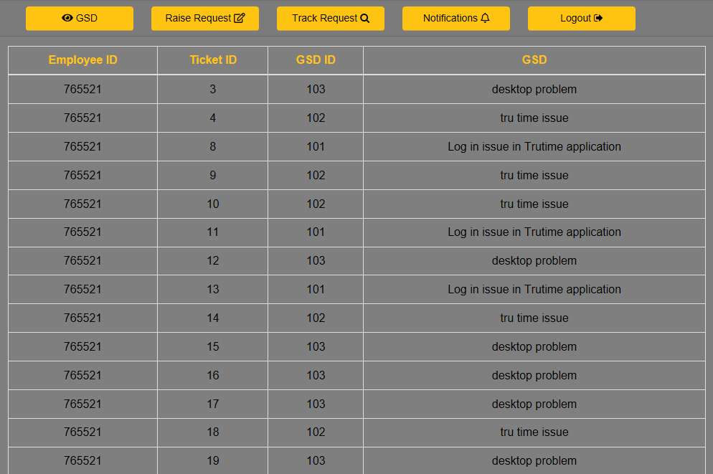

Here is a prototype of how the Notifications Tab will look like:

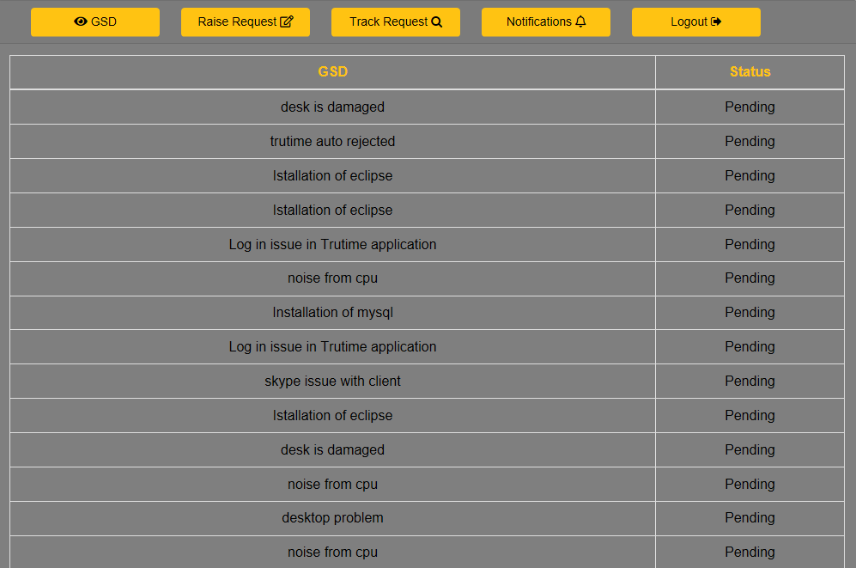

Database Design

Tables Structure
Admin Table:
Field Name | Field Type | Data Type | Mandatory | Possible Values
Admin First Name | Text(50) | Alphabetic | Yes
Admin Last Name | Text(50) | Alphabetic | Yes
Age | Numeric(2) | Numeric | Yes
Gender | Drop Down | NA |  | Male, Female
Contact Number | Text(10) | Numeric | No
AdminId | Text(15) | Alphanumeric | Yes
Password | Text(15) | Alphanumeric | Yes

User Table:
Field  Name | Field Type | Data Type | Mandatory | Possible Values
User First  Name | Text(50) | Alphabetic | Yes
User Last Name | Text(50) | Alphabetic | Yes
Age | Drop Down | NA | Yes | 18-120
Gender | Drop Down | NA |  | Male, Female
Contact Number | Text(10) | Numeric | No
Address | Scrolling text box(100) | Alphanumeric | No
City | Text(50) | Alphabetic | Yes
Zip Code | Text(10) | Numeric | Yes

GSD Table:
Field  Name | Field Type | Data Type | Mandatory | Possible Values
GSD Name | Text(50) | Alphabetic | Yes
GsdId | Numeric(20) | Numeric | Yes

Notifications Table:
Field Name | Field Type | Data Type | Mandatory | Possible Values
NotificationId | Text(50) | Alphabetic | Yes
NotificationType | Text(50) | Alphabetic | Yes
NotificationText | Text(50) | Alphabetic | Yes | 18-120

Change Log
Version Number | Changes Made
V1.0 | Initial baseline created on 22/05/2019 by Vijay Anand.
V1.1 | User Interfaces added on 28/05/2019 by V.Gnaneshwari and A. Ishwarya.

